Chapter 4

4 system design

4.1 Overview of system design

System design is the process of defining the architecture, modules, interface, component and data for a system to satisfy specified requirement system design could be seen as the application of system theory to product development (the process of solving a problem)

It is a process of planning a new business system or replacing an existing system by defining its components or modules to satisfy the specific requirement meanly it focus on how to accomplish the objective of the system

System design a mechanism of transformation the analysis model into system design model so our system design documentation is providing an application of traffic control management system specifically for the current city we live on(Adama) the system design includes purpose of the system design, design goals

4.1.1 purpose of the system design

The mean purpose of the system design is to give a clear understanding to the user how the application operates and how to implement it. the system design helps the user to understand the working environment of the application within short period of time and to maintain a sustainable relationship between the user and the app which is going to be developed finally the application may need a change in the future the user can be able to implement the change easily

4.1.2 design goal

The goal of the design is to show the system with high quality and standards the design goal are derived from nonfunctional requirement so the nonfunctional requirement are the description of the feature behavior ,character and attribute of the system as well any boundary that limit the application(TCMS) with boundary TCMS has been designed to be easy to use, robust, open and provide a broad functionality When designing TCMS, we had several major design goals in mind this document gives more data

* Functionality
* Usability
* Reliability
* Performance

Functionality

Functionality is of obvious importance. We can only expect wide acceptance of our software, if it is able to save the potential user a major amount of time. Thus, it should provide most of the standard functionality and leave only the implementation of specialized or new techniques to the user. And even there the user should be able to take advantage of existing data structures to speed up the development

Usability

Usability is assessed by considering human factor consistency and documentation on human factor we will provide a tutorial how to use the application how to implement it and mechanism of error preventing and before implementing the application we will experience them how to use the application

Reliability

TCMS(ATCMS) must be reliable, we had used several approaches to maintain the reliability of the system

We tried to estimate the frequency and severity of failure depending on the research we done we estimate the frequency of failure of system the system may fail with two cases the first it may fail due to the loss of connection with the internet if this happen we provide other bearer like SMS sending SMS to the local data base the second failure

the other thing when the user tried to search the system must provide is consistent result with short period of time in order to gain the result they want we inform them to use android device with version 4.2 or above and the device that allow them to access 3G,4G networks

the last thing is to recover if the whole system fail we provide a backup system that take back app every 24 hours

performance

The system should respond fast with high throughput, i.e. it should perform the task quickly possible as possible such as generating report and receiving new notification viewing report and also must provide information as fast as possible etc. The system performs its task within a user acceptable time and space. This includes the following:

Responses time depending on the types of information requested the system and the working network must response with time less than 5 s

Resource consumption depending on the research we collected the current system consumes more than a small city one-year budget but our system per police officer it consumes 15 Ethiopian birr on the road authority it cost 1000 - 2000 per month so it nothing comparing with the current system

Memory(storage) for the installation of the application it requires 50 -100 MG on phone for pc 50GB-100GB with minimum RAM requirement 0.5GB up 1GB and the server requires above 50GB storage

Configuration

Our system provide service as per data provided in configuration file

4.2 Proposed system Architecture

In this project, the team uses a three-tier architecture, which has three layers. These three layers are the Application or Presentation layer, the business layer and the data access layer. Application or presentation layer is the form, which provides the user interface to either programmer or end user. The business layer is the class, which the team uses to write the function, which works as a mediator to transfer data from application layer or presentation layer to data layer. This layer also has a property layer which is a class where variables are declared corresponding to the fields of the database which can be required for the application and make the properties so that the team can get or set the data using these properties into the variables. The third tire is the data access layer which is also a class to get or set data to the database queries back and forth. This layer only interacts with the database. The database queries or stored procedures will be written here to access the data from the database or to perform any operation to the database.

System Architecture

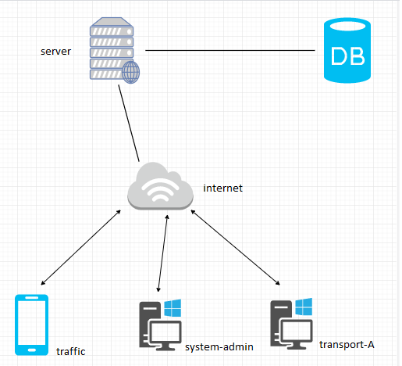

System process

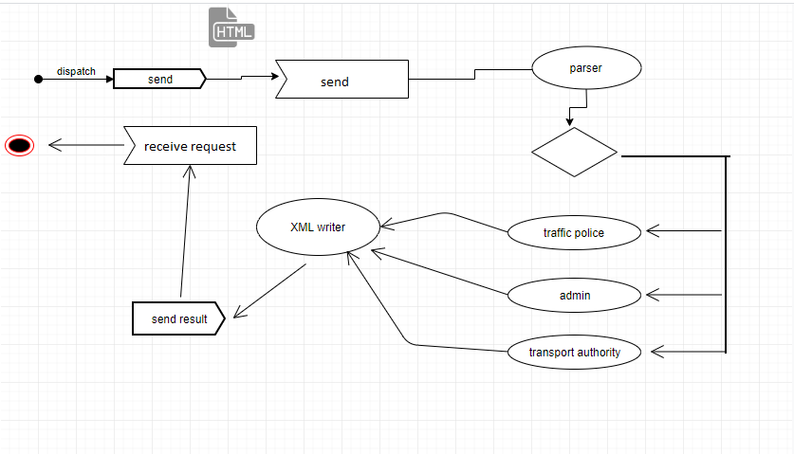

Traffic police

This section explores in detail traffic police system architecture design. A top-level overview of the system, a brief overview of system processes or functionality are described in the below section

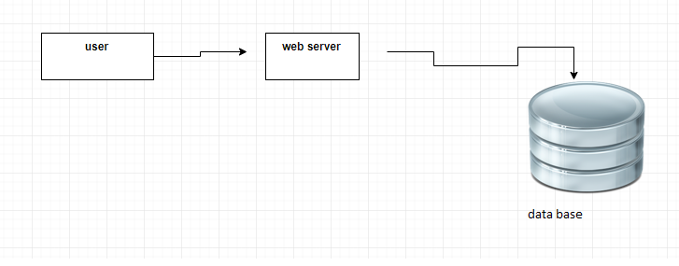

The figure shows traffic police system overview in relation to other components

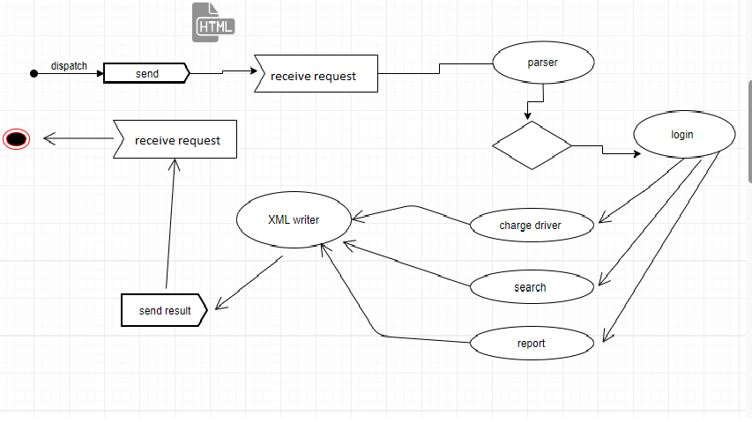

Administrator

This section explores in detail administrator system architecture design. A top-level overview of the system, a brief overview of system processes or functionality are described in the below section



The figure shows administrator system overview in relation to other components

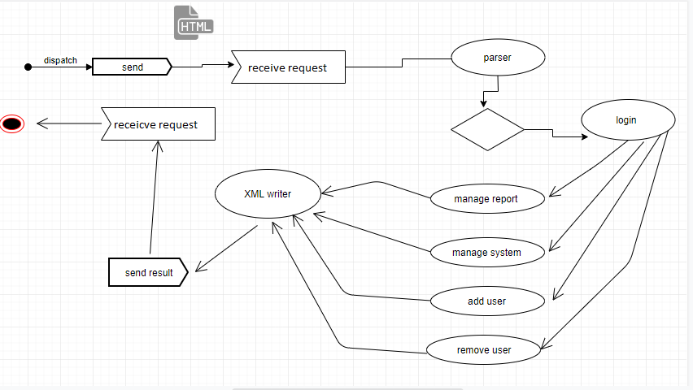

Transport authority

This section explores in detail transport authority system architecture design. A top-level overview of the system, a brief overview of system processes or functionality are described in the below section



The figure shows administrator system overview in relation to other components

